Biographies
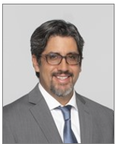 Dr. Eduardo Mireles-Cabodevila serves as the Medical Director of the Simulation and Advanced Skills Center at Cleveland Clinic. He is dedicated to advancing education and patient care through simulation-based training. His work focuses on mechanical ventilation, respiratory failure, and neuromuscular respiratory care. As the Director of the SEVA (Standardized Education for Ventilatory Assistance) program, he uses innovative teaching methods, including simulation and interdisciplinary collaboration, to set new standards in critical care education.

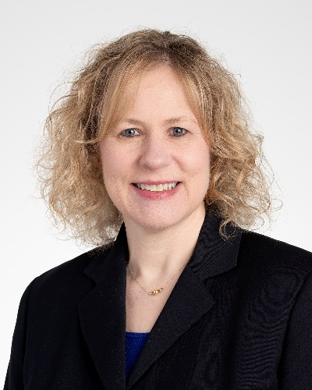 Kathleen Mau, DNP, APRN, is the Senior Director for Cleveland Clinic’s Simulation and Advanced Skills Center (SASC). In collaboration with the SASC Medical Director, Kathleen sets the overall direction and strategic priorities for the center. She provides direction and leadership of operational, programmatic, academic, and personnel activities related to simulation education and SASC operations. Kathleen also co-leads the Global Simulation Advisory Board with the goal of aligning and sharing best practices in simulation across the organization. Prior to this role, Kathleen worked in many inpatient clinical settings but specialized in emergency nursing. As a Clinical Nurse Specialist, she developed and led the stroke program at Medina Hospital and was the clinical lead for developing and rolling out Vital Scout, an enhanced electronic early warning system. She joined the Office for Nursing Education and Professional Development as a Sr. Director in 2018, where she led a variety of programs including nurse leader development, students and faculty, and nursing support caregiver orientation. She transitioned to her current position with the simulation center in 2023.

